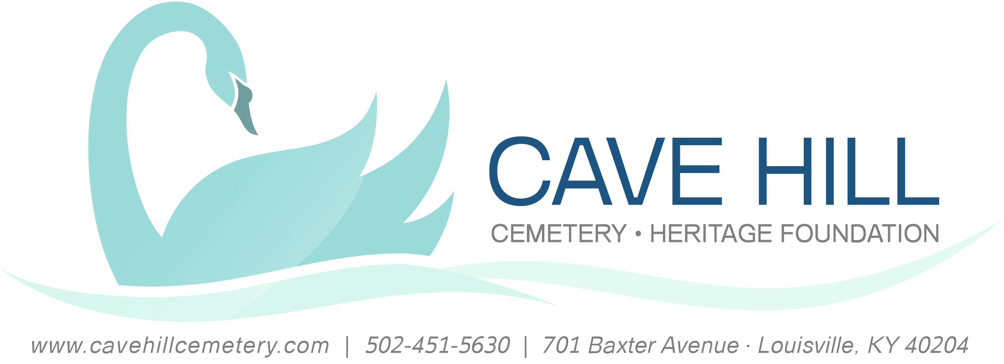

Official Rules

The Views of Cave Hill Cemetery
Sponsor: Cave Hill Heritage Foundation, Inc.

Term
The Views of Cave Hill Photography Contest begins January 1, 2016 at midnight U.S. Eastern Time and ends September 23, 2016, 11:59 p.m. U.S. Eastern Time. Information on how to enter and prizes form part of these official rules (“Official Rules”). By submitting an entry, each entrant agrees to the Official Rules and warrants that his or her entry complies with all requirements set out in the Official Rules.

Who May Enter
Contest is open to anyone that has visited Cave Hill Cemetery and taken photographs, 18 years old or older, or with appropriate parental consent if younger than 18 years of age.

How to Enter
This contest is FREE to enter. Visit www.cavehillcemetery.com; complete an entry form with the required information, including your name, address, telephone number, email address, and photo caption; and submit along with your photograph(s) in accordance with the instructions that follow. No entrant may submit more than (4) entries.

Each entry must comply with the following requirements (the “Photographic Requirements”):

To enter the contest:
Entry form and each photograph should be mailed to Cave Hill Heritage Foundation, Attn: J. Michael Higgs, 701 Baxter Avenue, Louisville, KY 40204.
- Prints are to be 80 square inches (i.e. 8” x 10”)
- Prints must be matted. Matting size: 11” x 14”
- Entrant’s name, address, phone number and caption for each photograph should be printed on the back of the matting for each photograph.
- Framed prints and prints under glass will not be accepted.

If you are determined to be a winner:
Digital images should be submitted along with the Entry Form and Personal Release found online at www.cavehillcemetery.com. Images should be formatted to 300 dpi, and no larger than 2640 by 3300 pixels. The entry form and photograph(s), with category specification, are to be emailed to michael@cavehillcemetery.com. Panoramic photos are not eligible. Images should be submitted in JPG (at high quality) format. Images must be in natural color. Digital images will not be returned. Black and white photos will be permitted in this year’s contest.

Image Modifications:
Minor digital enhancement is permitted, but images that have been significantly modified or appear unnatural will be disqualified.
Not permitted:
- No borders or frames may be added to images
- No watermarks, signatures, or copyright notices may be added to images.
- Adding or replacing elements in an image is not permitted.
- Artistic filters are not permitted.

Permitted Modifications:
- Images may be cropped and rotated as necessary as long as the rectangular format is maintained and the size is within the specifications above.
- Images may be resized as long as the aspect ratio is maintained.
- One-step enhancement (such as “Autofix”, “QuickFix”, “Auto Levels”, etc.)
- Use of filters to sharpen, soften, blur, or despeckle.
- Use of corrective functions to improve the natural appearance of the image, such as levels, contrasts, brightness, curves, intensity, tone, hue, saturation, lightness, value, color balance, and tint.

Photographs that include sculptures, statues and other works of art will be accepted as long as they do not constitute copyright infringement or fraud or prominently display a family name. Photographs of stained glass windows, interiors of private family mausoleums, or funeral services/processions will not be permitted. Only the natural setting of Cave Hill Cemetery is to be depicted. By entering in the contest, the entrant certifies that no other party has any right, title, claim, or interest in the photograph. The photograph must not, in the sole and unfettered discretion of the Sponsor, contain obscene, provocative, defamatory, sexually explicit, or otherwise objectionable or inappropriate content.

Winners will be required to sign a Personal Release and return it within (5) days following an attempted notification.

Contest Prizes
The winner for each month will receive an assortment of prizes, including gift certificates and or admission to local historical organization(s).

Judging
Contest consists of (2) rounds of evaluation for each season of the year. In round one, each judge in a panel of photographic experts will select (6) entries for each season from all eligible entries based on the following criteria (“Judging Criteria”): (1) Creativity 33.33%; (2) Photographic quality 33.33%; and (3) Effectiveness in conveying the beauty and/or unique character of Cave Hill Cemetery 33.33%. The entries selected in round one will proceed to round two. In round two, the Judges will collectively select a First, Second, and Third place winner for each season. Winners will be chosen on or around October 5, 2012, and notified by email. Decisions of the judges are final and binding.

License
By entering the Contest, all entrants grant an irrevocable perpetual, nonexclusive license to Authorized Parties, to reproduce, distribute, display, and create derivative works of the entries (along with a name credit) in connection with the Contest and promotion of the Contest, in any media now or hereafter known, including, but not limited to: display at a potential exhibition of winners; publication of a book, magazine, or newsletter article. Display or publication of any entry on an Authorized Party’s website does not indicate the entrant will be selected as winner. Authorized Parties will not be required to pay any additional consideration or seek any additional approval in connection with such use. Additionally, by entering, each entrant grants to Authorized Parties the unrestricted right to use all statements made in connection with the Contest, and pictures or likenesses of Contest entrants, or choose not to do so, at their sole discretion. Authorized Parties will not be required to pay any additional consideration or seek any additional approval in connection with such use.

Limitation of Liability
By entering this Contest, all entrants agree to release, discharge, and hold harmless the Cave Hill Heritage Foundation and its partners, affiliates, subsidiaries, advertising agencies, agents, and their employees, officers, directors, and representatives from any claims, losses, and damages arising out of their participation in this Contest or any Contest-related activities and the acceptance and use, misuse, or possession of any prize awarded hereunder.

Conditions
The Sponsor reserves the right to verify the validity and originality of any entry and/or entrant (including an entrant’s identity and address) and to disqualify any entrant who submits an entry that is not in accordance with these Official Rules or who tampers with the entry process. Failure by the Sponsor to enforce any of its rights does not constitute a waiver of those rights.

Right to Cancel or Suspend Contest
The Cave Hill Heritage Foundation has the right to cancel the contest for any reason at any time.

Winners List
Entrants are responsible for complying with these Official Rules. Winners names will be available by contacting the Cave Hill Heritage Foundation office by email at: michael@cavehillcemetery.com and titling the email “Winners List Request”. Alternatively, the winners list may also be requested by sending a self-addressed, stamped envelope to Cave Hill Heritage Foundation, Attention: J. Michael Higgs, 701 Baxter Avenue, Louisville, KY 40204.

